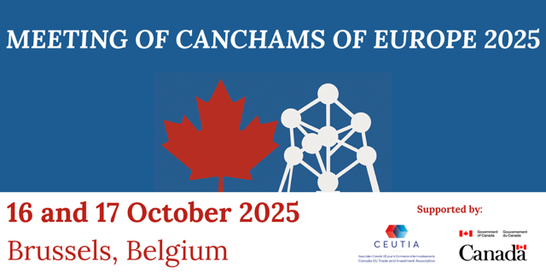

DRAFT

Agenda for Meeting of CanChams of Europe:

Thursday 16 October to Friday 17 October 2025
Avenue des Arts 57, 1000 Brussels

(in person at the Canadian Mission to the EU, Brussels)

Event Organized by the Canada EU Trade and Investment Association

Wednesday 15 October

17.00 – 18.30
- Introduction by Mark Camilleri, President, Canada EU Trade and Investment Association
- Welcome reception – remarks by Ambassador Nicholas Brousseau, Ambassador of Canada to Belgium and Luxembourg and Chargé d’affaires of Mission of Canada to the European Union
- Welcome Remarks by: Representative of CanCham Belux

Canadian Mission to the EU (Av. des Arts 57, 1000 Bruxelles, Belgium)
Event is co-hosted by CEUTIA and the CanCham Belux

Thursday 16 October

Private meeting of CanChams – 9 – 4pm

Time

8.45 – 9.00 | Arrival of delegates and registration  Canadian Mission to the EU  Av. des Arts 57, 1000 Bruxelles, Belgium  * Passport/National ID required at security check-in
9.00 – 9.15 | Welcome and Opening Remarks  - Mark Camilleri, President, Canada EU Trade and Investment Association  - Callie Stewart, Counsellor and Head of Section (Economics, Trade and Technology), Mission of Canada to the European Union
9.15 – 9.35 | Rollcall and introduction by representatives
9.35 – 9.40 | Overview of agenda and meeting goals, Mark Camilleri
9.40 – 10.10 | Updates on trade diversification initiatives in Europe and key takeaways from CanCham gatherings in the Indo-Pacific region  - Presentation by Danielle McDaid, Deputy Director, Strategic Trade Engagement at Global Affairs Canada  - CanCham Q&A
10.10 – 10.40 | Update from provincial government representatives on European strategy  - Presentations by:  - Provincial representatives (Québec, British Columbia, Alberta, and Manitoba)  - CanCham Q&A
10.40 – 11.00 | Break
11.00 – 12.30 | Vision exercise for the Future of the CanChams of Europe Network  Interactive breakout sessions based on Vision document produced by CEUTIA to generate ideas and set direction  - Small group discussions on key points ( 6 participants per group)  - Group discussion (45 min)
12.30 – 13.20 | Lunch
13.20 – 13.30 | Update from ED on European strategy  - Presentation by: Klaus Houben, EDC  - CanCham Q&A
13.30 – 14.30 | Strengthening Individual Chambers: Exchange of Best Practices (moderated discussion)  Some suggested topics of conversation:  - How do you manage succession and governance challenges?  - What are best practices in terms of revenue generation?  - How do you maintain a balance between Canadian and local country membership?  - What defines the strengths of your Chamber offering to your membership?  - Where are the areas of mutual support that the Chambers can offer to each other?  - What kind of resources can the Chambers develop that are useful across the region (e.g. database, document sharing, region wide calendar of events)  - What kind of joint events or exercises would be beneficial to Chambers across the region?  - How to collaborate effectively with Canada’s Senior Trade Commissioners and trade teams in diplomatic mission?
14.30 – 15.00 | Break
15.00 – 16.00 | Next Steps  - Consolidation of breakout outcomes and best practices  - Identifying areas for coordinated action (joint events, advocacy, communications)
16.00 – 16.10 | Closing of Meeting

- Dinner

La Maison du Cygne*
Grand Place 9
1000 Brussels
(Private room booked)
18.30 - 22.30

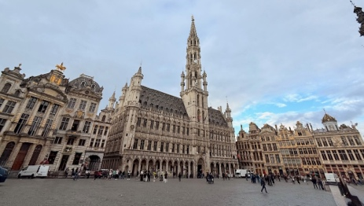 | 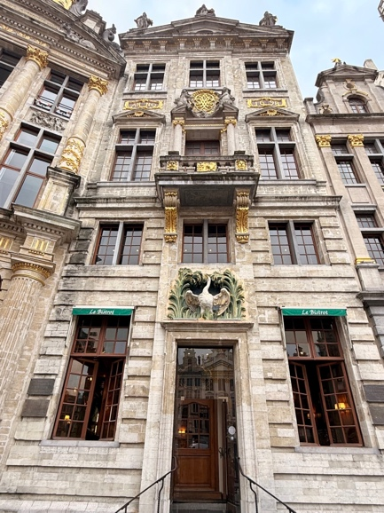 | 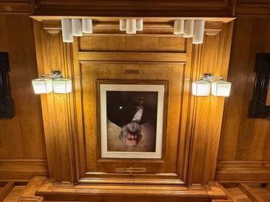

* a famous landmark within a famous landmark (the Grand Place). In 1848, Karl Marx and Friedrich Engels chose La Maison du Cygne as the setting for their famous Communist Manifesto. This emblematic site on the Grand-Place was a crossroads of revolutionary ideas, marking world political history.

Friday 17 October

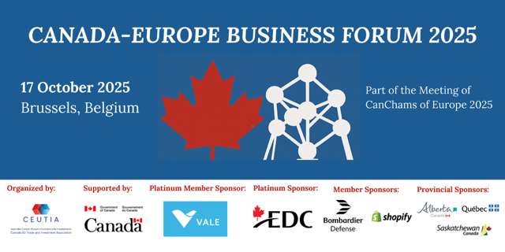

Time

7.45 – 8.00 | Arrival of CanChams and registration  Canadian Mission to the EU  Av. des Arts 58, 1000 Bruxelles, Belgium  * Passport/National ID required at security check-in
8.00 – 8.40 | CanChams conversation with Sara Wilshaw, Senior Assistant Deputy Minister and Chief Trade Commissioner  ESPACE CANADA ROOM
8.30 – 9.00 | Arrival and registration of other invitees to Canada-Europe Business Forum
9.00 – 9.04 | Opening of Canada-Europe Business Forum, Mark Camilleri, President of the Canada EU Trade and Investment Association
9.05 – 9.10 | Welcome and Opening Remarks  - Ambassador Nicholas Brousseau, Ambassador of Canada to Belgium and Luxembourg and Chargé d’affaires of Mission of Canada to the European Union
9.10 – 10.15 | Partners in Resilience: Advancing Canada–European Industrial and Defence Cooperation  This panel will examine how Canada and Europe can deepen collaboration in industrial and defence sectors to enhance shared economic and strategic resilience. Featuring perspectives from both government and industry, the discussion will highlight opportunities for cooperation in advanced manufacturing, defence technologies, and critical raw materials - emphasizing the importance of working together on common priorities, secure supply chains, and innovation to strengthen collective competitiveness in an evolving global landscape.  - Kerstin Jorna, DG, DG GROW  - Sofia Bournou, BusinessEurope  - Spencer Page, Vale  - Burkard Schmitt, Defence & Security Director, ASD  - Pierre Pyun, Bombardier Defence  - Jozsef Hajdu, CAE  Moderator: Callie Stewart, Counsellor and Head of Section (Economics, Trade and Technology), Mission of Canada to the European Union
10.15 – 10.45 | Keynote address, Rob Stewart, Canadian Deputy Minister of International Trade  + Q&A (Moderated by Mark Camilleri)
10.45 – 11.00 | Networking and Health Break  [CanCham Group photo with the Deputy Minister in adjoining room]
11.00 – 11.40 | Digital Horizons: Advancing Canada–European Cooperation on Trade and Technology  This panel will explore how Canada and Europe can deepen cooperation in digital trade and emerging technologies to drive inclusive growth and innovation. With artificial intelligence, cybersecurity, and data governance at the forefront of global economic transformation, participants will discuss how Canada and Europe can align their approaches to ensure open, secure, and trusted digital markets (including through a Canada-EU Digital Trade Agreement), while fostering collaboration between policymakers, innovators, and businesses across both regions.  - Agata Gerba, Digital Trade, DG Trade  - Kostas Rossoglou, Shopify  - Pascal Kerneis, European Services Forum  Moderator: Canadian Chamber of Commerce
11.40 – 12.15 | Trade Diversification Panel Discussion  - Moderator: Marie-Michelle Poulin, Director General, Regional Network, Intergovernmental Relations and Trade Missions at Global Affairs Canada  - Sara Wilshaw, Canada’s Chief Trade Commissioner and Senior Assistant Deputy Minister of International Trade at Global Affairs Canada  - Klaus Houben, EDC  - Rep of Canadian Chamber of Commerce
12.15 | Closing of Canada-Europe Business Forum, Mark Camilleri, CEUTIA
12.15 – 13.30 | Networking lunch

* * * * * * * * * * * * * * * * *

Please note that by participating in this event in person or online, you consent to (a) having your names and professional data shared with the event organizers and within the group, and (b) to being photographed, filmed and/or otherwise recorded. By registering to the event, you give the organizers the right to use such data for non-commercial purposes, including the posting of photos and/or videos on our websites.

